Creating a Shadow
Duplicate the track you want to add a shadow to, then pull it under the main track.
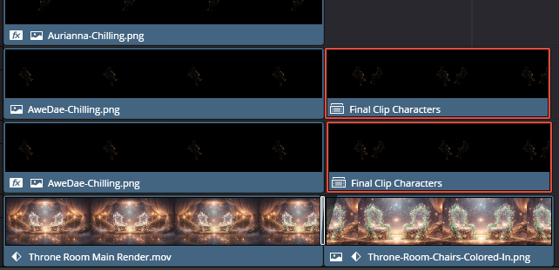
Go to the Color page
Use Gain on the Color page to do this. Gain controls Highlights or Brightness. On the color page you do not turn something black by increasing the shadow’s setting, you turn it to black by removing the brightness, and Gain is how you remove brightness.
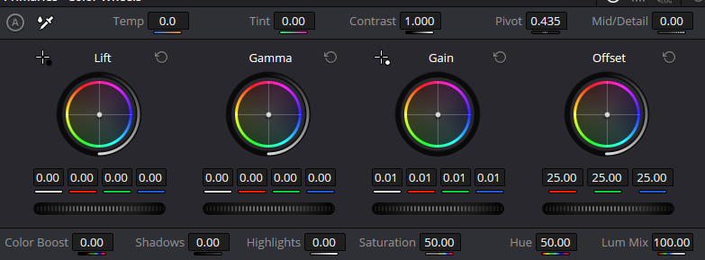
In order to remove the glow from the sleeve, which is very bright. I had to set Gain down to 0.01, which is 1 away from pitch black. You only have Gain to work with here because Gamma and Lift is 0 by default, there is no lowering that you can get away with there.


- Apply:
👉 Gaussian Blur (soften it)
Go Back to the Edit Page. Now go to Effects at the top and choose Gaussian Blur
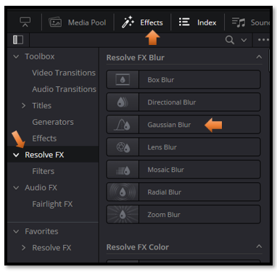

Then:
- Lower:
👉 Opacity (20–40%)

Position it slightly:
- Downward
- Slightly toward the chair surface

🎯 What this does
Creates a:
👉 fake contact shadow
